parameters.yml:root, 3306
create database чрез yml:
php bin/console doctrine:database:create

create entities:
php bin/console doctrine:generate:entity
AppBundle:Car >
make,
model,
travelledDistance(string:bigint)
AppBundle:Sale >
discount(string:float)
AppBundle:Customer >
name,
birthDate(string:date),
isYoungDriver(string:boolean)
AppBundle:Part >
name,
price(string:decimal, scale:2)
quantity(string:integer)
AppBundle:Supplier >
name,
isImporter(string:Boolean)
========================================================
@ORM Table(name= множествено число)s
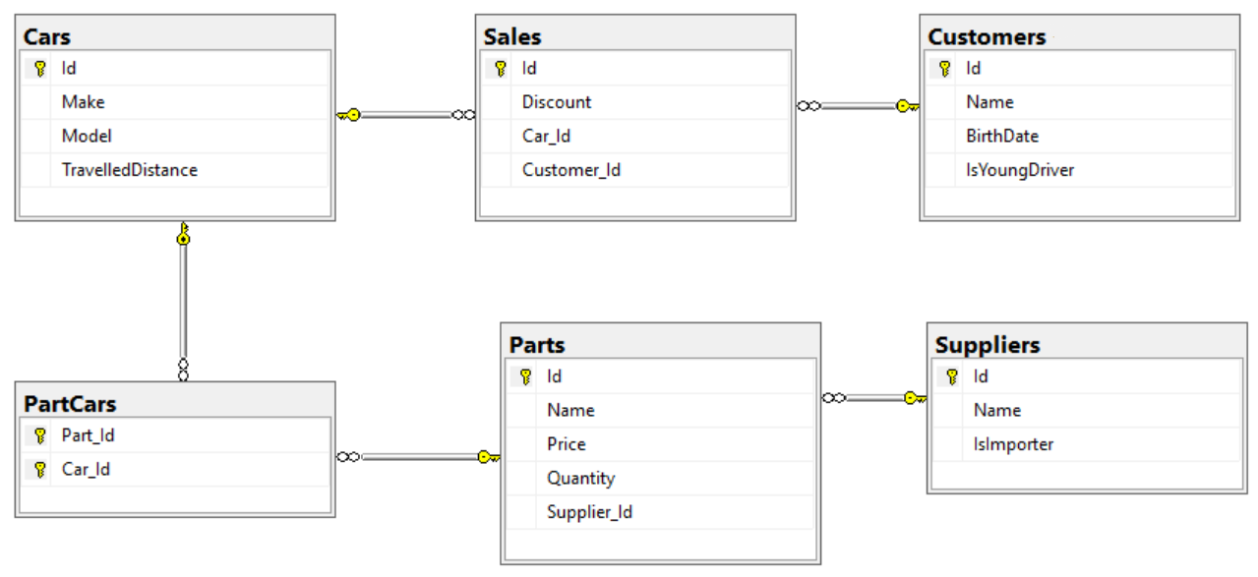
--in one sale only one car can be sold
oneToOne between Sales / Cars:
Sale:
private $car → @annotations

--Each sale has one customer and a customer can buy many cars
oneToMany between Sales / Customers
Customer:
private $sales...ArrayCollection
Sale:
@ORM\ManyToOne(targetEntity="AppBundle\Entity\Customer",inversedBy="sales")
@ORM\JoinColumn(name="customer_id", referencedColumnName="id")
private $customer;

--One supplier can supply many parts and each part can be delivered by only one supplier (Supliers / Parts)
Part:
@ORM\ManyToOne(targetEntity="AppBundle\Entity\Supplier", inversedBy="parts")
private $supplier;
Supplier:
* @var ArrayCollection|Part[]
* @ORM\OneToMany(targetEntity="AppBundle\Entity\Part", mappedBy="supplier")
private $parts;

--A car has many parts and one part can be placed in many cars
between Parts / Cars
Car:
/**
* @var ArrayCollection|Part[]
* @ORM\ManyToMany(targetEntity="AppBundle\Entity\Part")
* @ORM\JoinTable(name="cars_parts",
* joinColumns={@ORM\JoinColumn(name="car_id", referencedColumnName="id")},
* inverseJoinColumns={@ORM\JoinColumn(name="part_id", referencedColumnName="id")})
*/
private $parts;
Part:
/**
* @var ArrayCollection|Car[]
*
* @ORM\ManyToMany(targetEntity="AppBundle\Entity\Car", mappedBy=”parts”)
*/
private $cars;
===========================================================
install Migrations:
composer require doctrine/doctrine-migrations-bundle "^3.0" / or ^1.0
register bundle:
- AppKernel:
new Doctrine\Bundle\MigrationsBundle\DoctrineMigrationsBundle()

- config.yml:
doctrine_migrations:
dir_name: "%kernel.root_dir%/DoctrineMigrations"
namespace: Application\Migrations
table_name: migration_versions
name: Application Migrations
organize_migrations: false # Version >=1.2 Possible values are: "BY_YEAR", "BY_YEAR_AND_MONTH", false
==========================
creating migration:
php bin/console doctrine:migrations:diff
php bin/console doctrine:migrations:migrate
===========================================
Part: add getters and setters for supplier and car
Car: add getters and setters for parts

Supplier: add getter and setter for parts...
array parts by default is null , so:
__construct()...

CustomerRepository:
public function getAllCustomers

//generate entry and repositories:
>php bin/console doctrine:generate:crud
AppBundle:Car => (ent.....
===================
CRUD:
php bin/console doctrine:generate:crud
AppBundle:Part(write actions: yes)

